The Ministry of Foreign Affairs of Denmark  Asiatisk Plads 2  DK-1448 København K  Denmark  Submit report to dgbp@dgbp.dk | 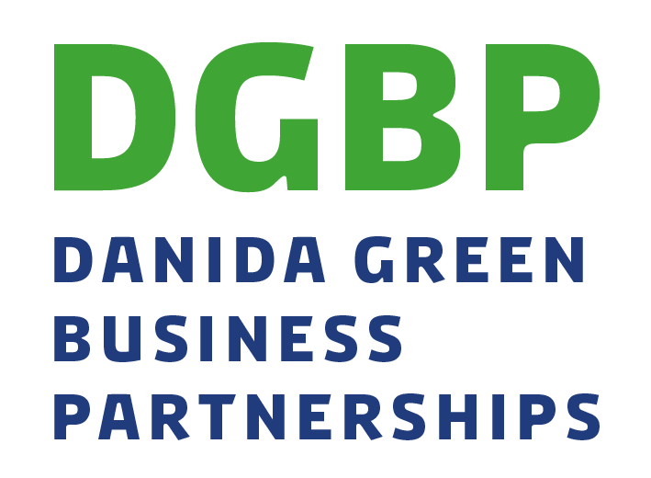  Narrative Completion report – Maturation projects
Project Title:
 | Ref. no.: | Date:

This report should be submitted upon completion of the project implementation and after final audit. The report should be approximately 5 pages long.

Please send the report including any relevant annexes by email.

The administrative partner hereby certifies the correctness of this document and its annexes by two mandated signatories.

Date: __________________________ Date: __________________________

Name: __________________________ Name: __________________________

Title: __________________________ Title: __________________________

Signature: __________________________ Signature: __________________________
The key commercial partner hereby certifies the correctness of this document and its annexes by one mandated signatory.
Date: __________________________

Name: __________________________

Title: __________________________

Signature: __________________________

General information and financial reporting

1a. Administrative partner
Address
Post code/city
Contact person
Telephone no. |  | Mobile phone | Email-address
1b. Key commercial partner
Address
Post code/city
Contact person
Telephone no. |  | Mobile phone | Email-address
2. Other commercial and on-commercial partner organisation(s)  [Insert additional rows, if more partners] |  |  |  |  | Type of partner (mark with X):  Commercial: __  Non-Commercial: ___
Address
Post code/city
Contact person
Telephone no. |  | Mobile phone | Email-address

3. Country and location(s) within country
4. Project period | According to original grant |  |  | Actual
Start (day/month/year)

Completion (day/month/year)
5. Total project expenditure | According to original grant budget |  |  | Actual
(in DKK)

6. Danida’s contribution to the project | According to original grant |  |  | Actual
(in DKK)
7. Partners’ own-contribution to the budget | According to original grant |  |  | Actual
(in DKK)
8. Other sources of financing (if any) | According to original grant |  |  | Actual
(in DKK)
9. Short project description
Short description of the project and its objective(s)

Reporting on results

10. Summary of results
Present a summary of the project’s most important results, challenges and lessons learned.
11. Results (outputs)
Please list the original outputs (or as modified and approved by the DGBP secretariat during project implementation) and describe achievements of the project. The below should focus the narrative; quantitative targets and indicators are reported on in a separate annex.
Output 1

Output 2

Output 3

Output 4

Output 5

Output 6

Output 7

Output 8

12. Effects – outcome
Please list the original intended outcomes of the project and assess to which degree the outcomes have been achieved incl. why/why not. Please make references to the selected indicators and relevant SDGs incl. targets.
In the description, ensure to focus on the duality in the project (both the climate/environment/social development outcomes and outcomes of the business case) and how the business case has led to achieving the climate/social development intervention.
Describe to which extent the project has contributed to the overall objective as formulated in the final project proposal.

Outcome 1
Outcome 2
Outcome 3
Outcome 4
13. DGBP programme level results

13a. DGBP Outcomes:
- Reduced vulnerability to climate change, reduced strain on natural resources and the environment and a stabilisation of GHG emissions
- Inclusive private sector growth and improved livelihoods
Indicator |  |  | End target according to latest approved target | Final results
- Climate and Environment Indicators |  |  |  | If result is none, please explain. Only report on the indicator applicable to your project.
1.1 Number of vulnerable persons/households who have increased their resilience to climate change as an effect of the partnership projects
Hereof youth (below 25)
Hereof women
1.2 Avoided GHG emissions (estimated CO2-equivalents)
1.3 Efficiency gained on the use of water, energy, materials and/or natural resources (percentage efficiency gains)
1.4 Area under sustainable land management (ha)
1.5 Reductions in the amounts of polluting substances released to soil, water bodies and/or air (percentage reduction)
- Inclusive private sector growth and improved livelihoods |  |  |  | Please report on all indicators
2.1 Number of decent jobs created with commercial partners (total)
Hereof women
Hereof youth (below 25)
2.2 Number of people with opportunities for increased income and/or improved livelihoods (total/female/youth)
Hereof women
Hereof youth (below 25)
2.3 Viable business case developed and sustained at the end of project period
2.4 Percentage of partner companies with responsible business conduct
2.5 Amount of private investments mobilized in partnership project (DKK)
13b: DGBP Outputs:
- Capacity of commercial partners increased (technical, commercial, RBC)
- Increased access to products or services for customers
- Increased capacity and access to markets for small-scale suppliers (eg., farmers)
Please translate and aggregate the project level output indicators to the DGBP output indicators. There may not be project level indicators/targets on all DGBP output indicators.

DGBP output indicators |  |  | End target according to latest approved target | Final results
Number of staff trained  (only staff of commercial partners):  (a) Technical  (b) Commercial/management  (c) Responsible business conduct |  |  | a)  b)  c)  Total: | a)  b)  c)  Total:
Hereof women
(percentage of total)
Hereof youth (below 25)
(percentage of total)
(a) Number of units sold  (b) Number of (potential) customers trained/reached |  |  | a)  b)  Total: | a)  b)  Total:
Hereof women
(percentage of total)
Hereof youth (below 25)
(percentage of total)
a) Number of suppliers trained  (b) Number of suppliers reached |  |  | a)  b)  Total: | a)  b)  Total:
Hereof women
(percentage of total)
Hereof youth (below 25)
(percentage of total)
14. Wider market effects
Describe whether the project has un-locked wider market effects (intended or un-intended)
15. Reporting on work with Responsible Business Conduct
Describe challenges, experiences, opportunities encountered and responses to these in the project’s work with Responsible Business Conduct.

16. Sustainability
- A brief description of how the project ideas and achievements will be carried forward (and scaled) after DGBP funding has ended (both climate/social development aspects and commercial aspects)
- Will the collaboration between the partners continue?

17. Communication
How have the lessons learned from the project period been documented and communicated? What has the aim with the different communication activities been and what has been achieved?
18. Challenges and adjustments
- Which challenges did the project have to consider and/or solve? (Unforeseen as well as identified risks, cf. the application).
- Which adjustments in the design of the project, including the budget, were carried out? (bullet form and explanation)

19. Lessons learned
Key lessons learned in different areas including:
- Working in partnerships
- Testing of business idea/proof of concept through a maturation project
- Outreach to specific target groups (women, men and youth)
- Implementation strategies that have worked well and less well
- Results reporting
- Etc..

20. List of documents drawn up in connection with the project’s implementation
Please list all the documents, that have been developed as part of project implementation and completion – including possible studies, revised project documents, project reviews and evaluation reports – as well as information material on (or in connection with) the project. Include links to the documents where relevant and submit key documents to the DGPB Secretariat.

Mandatory appendices to the Narrative Completion Report

The following annexes are mandatory for the completion report:
- Output level results reporting (format and guidance below)
- Outcome level results reporting (format and guidance below)
- Final Financial Statement (Annex 9 of administrative guidelines)

Output level results reporting
In this section, please report on the project’s yearly and final results against the indicators and targets defined in your approved results framework. All reporting (results) should be clearly marked.

Output 1: |  | Name of output 1
Output indicator |  | Indicator a  Indicator b
Baseline | 2022 | a. 0  b. 0%
Target | 202x | a. 200  Final result: 210  b. 20%  Final result: 15%

Outcome level results reporting
Please report on the project’s final outcomes against the indicators and targets defined in your approved results framework. All reporting (results) should be clearly marked.

Outcome 1: |  | Name of output 1
Outcome indicator |  | Indicator a  Indicator b
Baseline | 2022 | a. XX  b. XX
Final target | 2023/24 | a. XX  Final result: XXX  b. XX  Final result: XXX

