The Ministry of Foreign Affairs of Denmark  Asiatisk Plads 2  DK-1448 København K  Denmark  Submit report to dgbp@dgbp.dk | 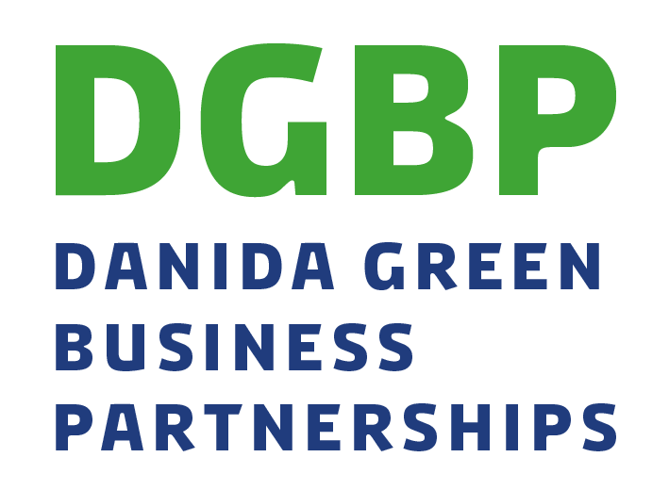  Yearly report
 | DGBP Ref. no.: 22F-xxxx | Date:

This report should be submitted annually by 28th February and consist of approximately 5-10 pages.
Please send the report including annexes by email.

The administrative partner hereby certifies the correctness of this document and its annexes by two mandated signatories.

Date: __________________________ Date: __________________________

Name: __________________________ Name: __________________________

Title: __________________________ Title: __________________________

Signature: __________________________ Signature: __________________________
The key commercial partner hereby certifies the correctness of this document and its annexes by one mandated signatory.
Date: __________________________

Name: __________________________

Title: __________________________

Signature: __________________________

1. Does this report contain information, which needs specific approval from the Ministry of Foreign Affairs? e.g. changes in the project’s output, expected results or budget.  (If changes have been approved in previous yearly reports, they do not need to be included again) |  | Yes |  | In which section are they described?  Please include request for reallocation, updated project document etc. as relevant
 |  | NO
2. Administrative partner
Address
Post code/city
Contact person
Telephone no. | Mobile phone |  | Email-address
2.a. Other partner organisation(s) and commercial partner(s)

3. Project title

4. Total budget (DKK) | 4a. Size of grant from MFA (DKK) |  | 4b. % of total MFA grant spent (accumulated from project start)

5. Country and location(s) within country

6. Project period
Start (day/month/year) | Completion (day/month/year) |  | Revised end date (and include date of approval by DMFA in brackets)
Progress in % so far
[number of months of implementation/months of project duration]
7. Period of reporting
Start (day/month/year) | Completion (day/month/year)
8. Short project description (from project document)
Short description of the project and its objective(s)

9, Issues to be discussed at the annual meeting
Indicate the issues that the partnership would like to discuss with the Secretariat at the annual meeting

Results framework
Please ensure that the below sections are closely aligned to the results framework of the project.

DGBP Programme level indicators:
DGBP Programme-level indicators | Unit | Baseline | Final target
- Number of vulnerable persons/households who have increased their resilience to climate change as an effect of the partnership projects (total/female/youth) | #
- Avoided GHG emissions (estimated CO2-equivalents) | CO2-e
- Efficiency gained on the use of water, energy, materials and/or natural resources (percentage efficiency gains) | %
- Area under sustainable land management (ha) | Ha
- Reductions in the amounts of polluting substances released to soil, water bodies and/or air (percentage reduction) | %
- Number of decent jobs created (total/female/youth) | #
- Number of people with opportunities for increased income and/or improved livelihoods (total/female/youth) | #
- Viable business cases developed and sustained at the end of the project period | #
- Percentage of partner companies with responsible business conduct | %
- Amount of private investments mobilised | DKK

Output level results framework:
Output 1: |  | Name of output 1
Output indicator |  | Indicator a  Indicator b
Baseline | 2022 | a.  b.
Annual target | 2023 | a.  b.
Annual target | 2024 | a.  b.
Annual target | 2025 | a.  b.
Annual target | 2026 | a.  b.

Progress and results reporting (max. 5 pages)

9. Description of activities, progress and results at output level
Describe key activities and related achievements during the past year.
Describe new opportunities in the project and any challenges experienced including (major) deviations from the set targets. Include what and how the project partners have worked with these opportunities/challenges

Make sure to attach an annex reporting on yearly results against project indicators in results framework. See proposal for format below.

11. Progress towards climate change and/or environmental effects
Reflect on the project’s progress at outcome-level towards climate change and/or environmental effects as defined in the results framework and project ToC

10. Progress towards creating development effects
Reflect on the project’s progress at outcome-level towards economic development and livelihood effects as defined in the results framework and project ToC.

11. Progress towards a viable business case
Reflect on progress towards developing a viable business case in the project
Include reporting on any new opportunities and/or challenges experienced by the commercial partners in their work with the project’s business case and how the project partners have worked with these

12. Wider market effects
Describe active steps taken by the projects to contribute to wider market effects.
Please reflect on whether the project has, or is on a path to un-lock wider market effects (intended or un-intended)

13. Development in important assumptions and risks
In the table below, list new assumptions and risks faced by the project. Also list any updates to previously identified risks. Please ensure to also include any risks identified in relation to the due diligence analysis carried out during project formulation, including follow up in relation to impact assessments (typically institutional risks). If further due diligence analysis has been carried out as a risk response, please annex this analysis to the report. Make sure to include updated risk matrix as an annex.
New (and update to existing) assumptions/risks | Assessment of development |  | Assessment of the likelihood and effect on the project implementation and description of proposed risk response
1.
2.
3. (please add rows as needed)
14. Budget revisions
Explain changes or reallocations within the budget (linked to section 13 and 14 above), if any.
Prior approval from the DGBP secretariat is required for reallocations above 10% between outputs in the annual budget. Reallocations of up to 10% between outputs in the annual budget can be made without prior approval from the DGBP Secretariat but should be reported on (see administrative guidelines).

15. Partner organisations (if relevant)
Describe any changes in the partnership set-up, including financing (e.g. new donors), new national cooperation partners etc.

16. Lessons learned
Key lessons learned by the different project partners during the reporting period (bullet points)
17. Yearly reporting on DGBP programme level outcome indicators
*please also report on any proposed changes to original targets as in the approved project document (or latest approved revisions)
Indicator |  | End target according to project document/latest approved target |  | Result so far (for the indicators selected in the project document)
- Climate and Environment Indicators |  | -- |  | report on the below indicators as agreed in the project document
1.1 Number of vulnerable persons/households who have increased their resilience to climate change as an effect of the partnership projects (women, youth, total) |  |  |  | If result is less than envisaged, please explain
1.2 Avoided GHG emissions (estimated CO2-equivalents)
1.3 Efficiency gained on the use of water, energy, materials and/or natural resources (percentage efficiency gains)
1.4 Area under sustainable land management (ha)
1.5 Reductions in the amounts of polluting substances released to soil, water bodies and/or air (percentage reduction)
- Inclusive private sector growth and improved livelihoods |  | -- |  | Report on all indicators
2.1 Number of decent jobs created (total/female/youth) |  |  |  | If result is less than envisaged, please explain
2.2 Number of people with opportunities for increased income and/or improved livelihoods (total/female/youth)
2.3 Viable business case developed and sustained at the end of project period |  |  |  | No yearly reporting required. Adjustments to target can be mentioned
2.4 Responsible business conduct |  |  |  | See methodology for scoring below
2.5 Amount of private investments mobilized in partnership project (DKK)
Notes and explanations:
18. Yearly self-assessment on Responsible Business Conduct
The DGBP results framework includes five steps in relation to RBC. Each year, the partners will make a self-assessment on progress, which includes a score and a justification for the scoring given. The table below includes guidance in relation to how many points to obtain by taking which initiatives.
Step in DGBP results framework |  | Guidance to points to obtain | Self-assessment – Points and justification
Step I: An initial screening must be carried out using e.g. the DGBP risk screening tool, the Global Compact Self-Assessment tool, or similar. |  | No initial screening – 0 points  Initial screening - 2 points | Please fill in
Step II: In case significant issues are identified, further and more detailed assessments must be carried out using tools which are benchmarking against international standards and that are internationally acknowledged |  | No detailed assessment – 0 points  Detailed assessment – 2 points | Please fill in
Step III: Formulate a brief Responsible Business Conduct Action Plan to account for how negative impacts will be addressed and monitored. |  | No RBC action plan – 0 points  RBC Action Plan formulated – 2 points | Please fill in
Step IV: Establish a system to ensure follow up and continuous improvement, including appointing a person from the key business partner with overall responsibility |  | No management system – 0 points  RBC responsible appointed – 2 points  And management system in place – 4 points | Please fill in
Step V: Report on monitoring and follow-up of the RBC Action Plan annually in the DGBP Yearly Report. |  | Not included in reporting – 0 points  Included in reporting – 2 points  Yearly sustainability report published – 4 points | Please fill in
19. Reporting on work with Responsible Business Conduct
Describe challenges, experiences, opportunities encountered and responses to these in the project’s work with Responsible Business Conduct.

20. Communication
With reference to the projects communication plan, please describe what communication events, material etc. has been produced and carried out, and approximately how much funding has been used so far (accumulated).

Mandatory appendices to the Yearly Report

The following annexes are mandatory for the yearly report:
- Output level results reporting (format and guidance below)
- Yearly financial report (Annex 15 of administrative guidelines)
- Disbursement request form (Annex 3 of administrative guidelines)
- Work plan for the coming year (use own format)
- Budget for the coming year (Annex 11 of administrative guidelines)
- Communication plan for the coming year (format and guidance to be found on DGBP website)
- Updated Risk Management Framework (use previously applied format)
- Responsible Business Conduct Action Plan (use previously applied format)
- Updated/revised overall budget (Annex 10)
- Bank statement as per 31. December

Please attach other relevant annexes (minutes from steering group meeting, studies undertaken, proposal for revised results framework etc)
Output level results reporting
In this section, please report on the project’s yearly results against the indicators and targets defined in your approved results framework. All reporting (results) should be clearly marked. An example of how yearly results reporting could look like is included hereunder.

Output 1: |  | Name of output 1
Output indicator |  | Indicator a  Indicator b
Baseline | 2022 | a. 0  b. 0%
Annual target | 2023 | a. 200  Yearly result: 210  b. 20%  Yearly result: 15%
Annual target | 2024 | a. 200  Yearly result: 180  b. 30%  Yearly result: 40%
Annual target | 2025 | a. 300  b. 50%
Annual target | 2026 | a. 100  b. 70%

Number of full-time equivalent employees as per local definition working in new or improved jobs under the framework of the project.
This is counted as the number of commercial partners with a viable business case in the developing country at the end of the project.
The investments mobilised is calculated as the total financial investment or value of equipment invested in the commercial partners during the project.
Number of full-time equivalent employees as per local definition working in new or improved jobs under the framework of the project.
This is counted as the number of commercial partners with a viable business case in the developing country at the end of the project.
The investments mobilised is calculated as the total financial investment or value of equipment invested in the project.

